**FOREST Portable Dental Unit NEW $359.00**

**Water bottle H2O feed**

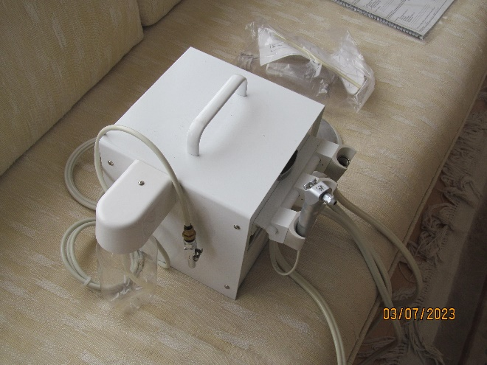

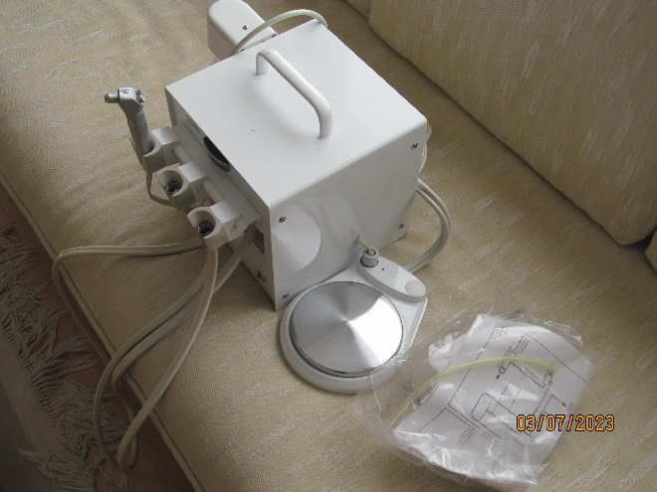

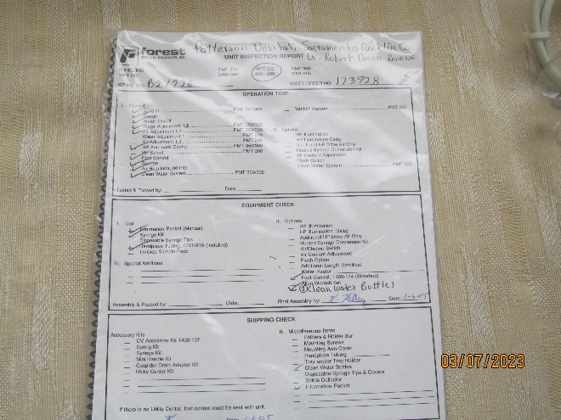

**Contact: Robert Devin DDS Call or text 775.997.4944**

