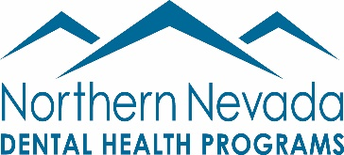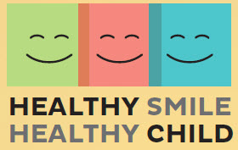

Northern Nevada Dental Health Programs/Healthy Child Healthy Smile

Dental Program Coordinator:

The Dental Program Coordinator will actively coordinate patient cases, assess and determine needs and support dental providers serving the patient. This position is responsible for all aspects of care coordination of dental services for patients participating in the Healthy Smile Healthy Child (HSHC) program, provides direct case management, and will track both patient and provider through the program. The Dental Program Coordinator follows up on referrals and implements the arrangements, including the in-kind of oral health services. Communication with internal staff, patient/guardian, and community dental providers must be accurate and timely, establishing community and provider relationships for strong service options.

Summary of Duties:
- Develops and coordinates system of referral intake, screening/eligibility, and scheduling patient for services according to patient/provider need for timeliness and capabilities.
- Fields inquiry calls and effectively explains services, options and requirements for participation in the HSHC program.
- Assess clients to determine eligibility and/or position on access fee. Verifies benefit status for scheduled dental services.
- Collects and process patient access fees as necessary, according to payment agreement.
- Coordinates logistical issues and accurately completes case documentation with patients.
- Collects and maintains necessary patient data in order to accurately and completely submit timely reports.
- Coordinates with community partners as needed to ensure adequate access and outreach for the program.
- Identifies, recruits, and retains dental providers in the community, as appropriate, available to provide treatment for targeted patients for HSHC.
- Schedules and confirms dental appointments with providers and patients and helps to solve issues or obstacles to keeping appointments as scheduled.
- Provides/obtains necessary case documentation to/from dentists in a timely manner.
- Maintains accurate and timely records of individual dental practices’ preferences, capabilities, and capacity to treat children.
- Drives to service sites, as necessary, to meet with patients or providers to obtain patient, provider, service, interpret, or benefit data.
- Maintains thorough and accurate documentation and patient, provider and payer data utilizing both paper and electronic systems such as Eaglesoft.
- Produces patient, provider, revenue/reconciliation, and program reports quarterly.
- Attend quarterly NNDHP board meetings, NNDHP Special Session Meetings if needed, and attends monthly Northern Nevada Dental Society (NNDS) membership meetings.
- Coordinates and implements NNDHP Give Kids a Smile events including placement of children needing additional care with NNDHP providers and coordinating all GKAS Committee meetings
- Other duties as assigned.

Page 2

Requirements:
- Highly organized
- Effective interpersonal and communication skills-Bilingual (preferred)
- Ability to work with families from a wide range of socio-economic backgrounds
- Proficient in Microsoft office, including Excel, Word and PowerPoint.

Experience (preferred) :
- Dental office experience 1-2 years
- Eaglesoft experience 1-2 years
- Case management experience 1-2 years

