SAFETY SHIELD GLASSES NEW
12 PAIR FOR $12.00

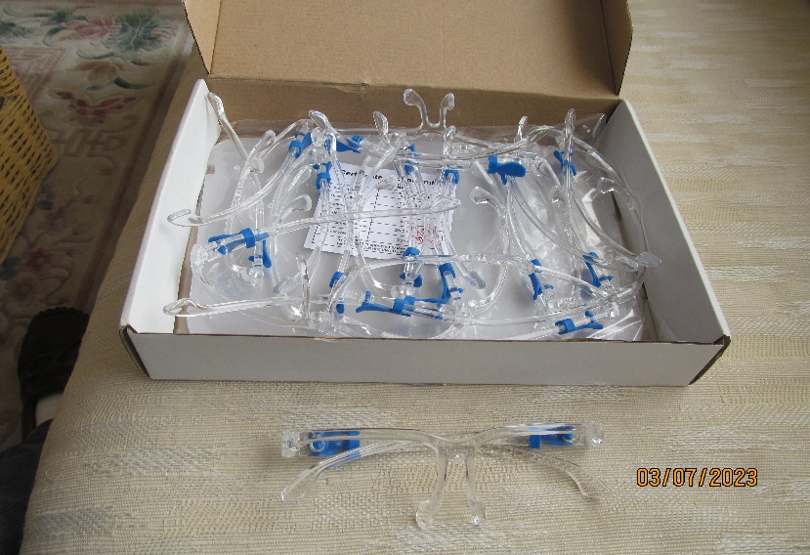
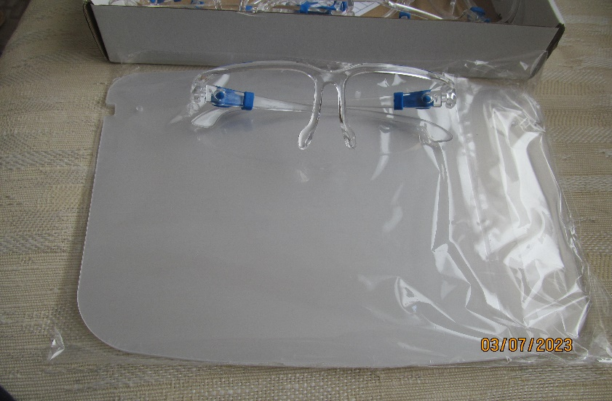
Contact: Robert Devin DDS Call or text 775.997.4944

PINNACLE EVAC CANISTER FLIERS
New $5.00 each Two available
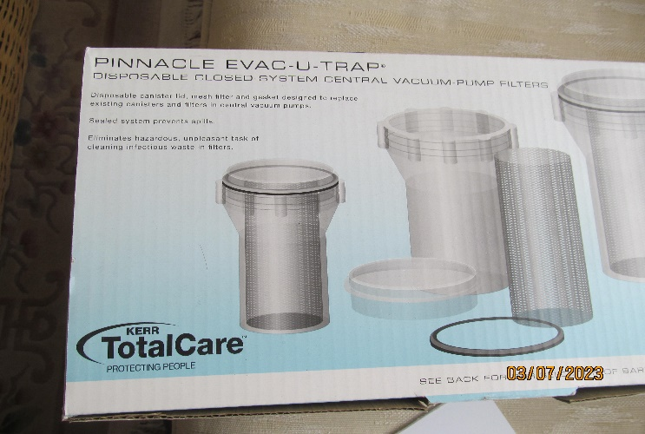
Contact: Robert Devin DDS Call or text 775.997.4944
