SOLMETEX Amalgam Separator
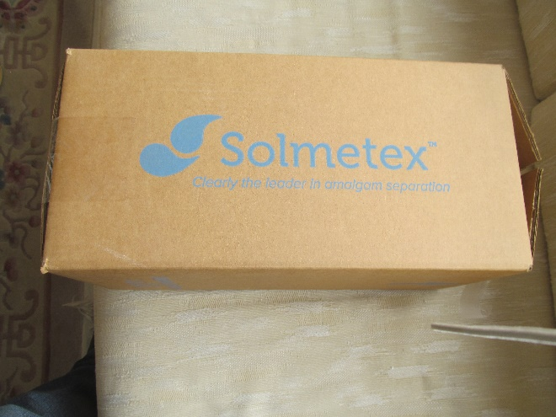
New $35.00
Contact: Robert Devin DDS Call or text 775.997.4944
