26th Annual Open House BBQ
&

Hosted by the
Northern Nevada Dental Society

Thursday, August 14, 2025
5:30 p.m. - dusk

For Members, new members, new dentists, prospective members and your families only please!
Bounce House, food, friends and family fun

Bartley Ranch Regional Park, Reno
Plaza Picnic Pavilion (behind main bldg.)
6000 Bartley Ranch Rd., Reno (off Lakeside Drive)

Catering from: Los 4 Vientos Carniceria & Catering & Churros Hueso’s
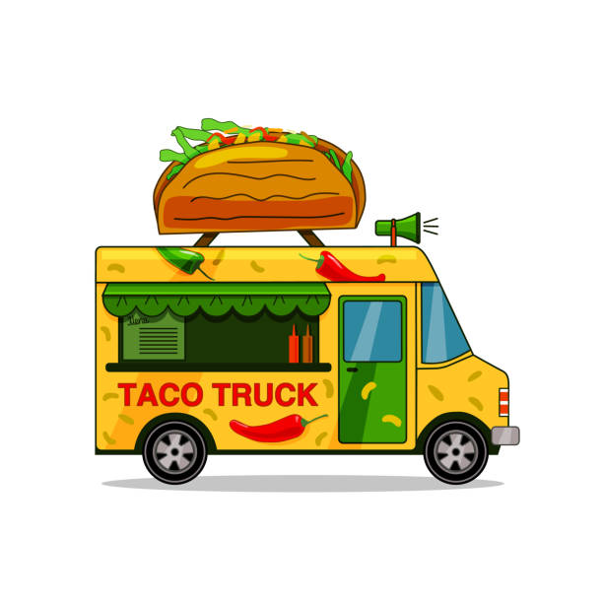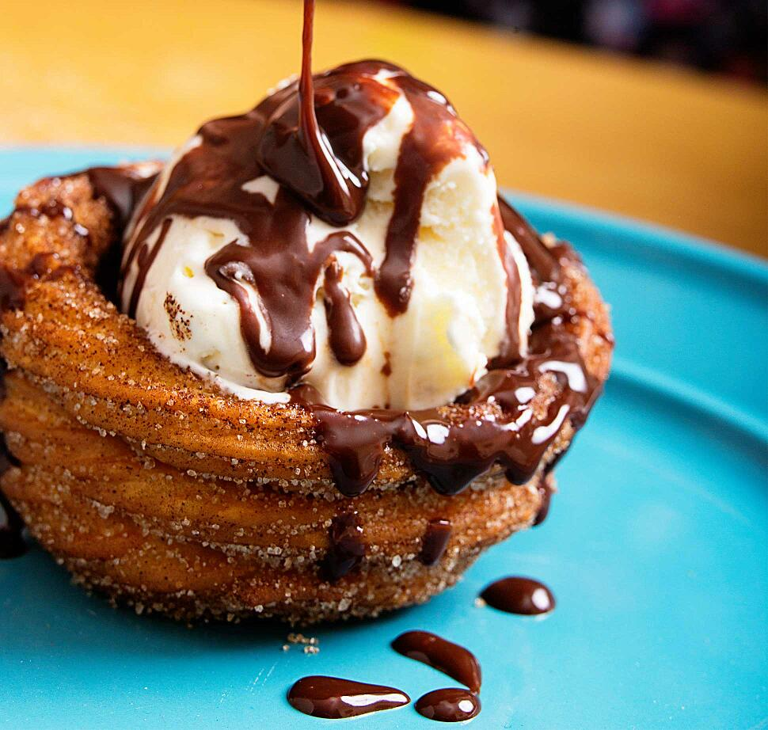

please contact Lori with your RSVP TODAY
Call (775) 337-0296 or FAX (775) 337-0298
E-mail: nnds@nndental.org or www.nndental.org

Hope you will join us! 