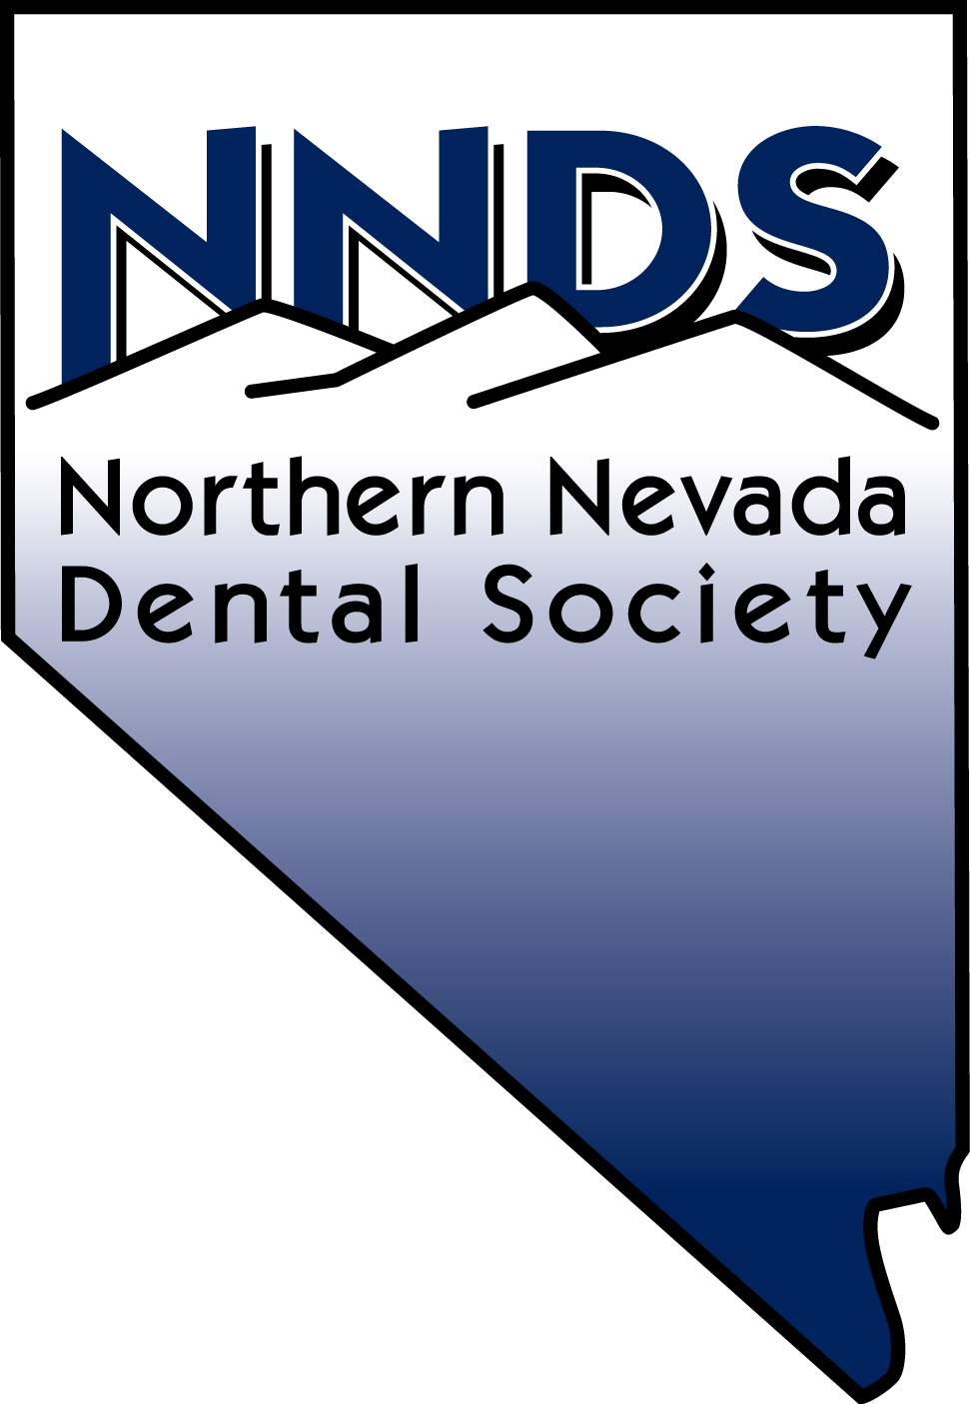
2025/26
Dear Corporate Vendor:

Thank you for contacting the Northern Nevada Dental Society regarding participation as a valued vendor. This year we have multiple tiers of sponsorship that we are confident will enhance your participation at one of our events and as a Corporate Partner.

Our dinner meetings begin with a cocktail hour at 6:00 p.m. and then a sit-down dinner at 7:00 p.m. We typically anticipate @ 60-120 dentists per month with some staff occasionally in attendance. Continuing education course attendance varies depending on the topic and guest speaker. Our events are in-person only, with some courses offered on demand.

The vendor tables I request from the hosting site are 6’ skirted; electrical supply and an additional table is available with prior notice. Wifi is complementary. The dinner format is business casual. Vendor tables are placed around the perimeter of the meeting room or near the bar area. See attached Corporate Sponsorship Opportunities as we welcome representative(s) from your company to address the attendees and we are offering more time to address the dentists depending on your level of sponsorship. Your meals will be served at your vendor table and certain sponsorship levels will now be given our beverage tickets to pass out to attendees. We want to give you as much facetime to interact with our attendees for the value, or you are welcome to sit with the dentists at our dinner meetings.

See attached Corporate Opportunities for a complete list of our 2025/26 Event Calendar. Our Vendor Night is a unique experience as all attendees must stop by your table in order for them to receive the CE credit and our annual Infection Control/OSHA course scheduled in May typically brings 300-450 dentists and staff. All meals at our events are included for 2.

Please complete the attached Vendor Sponsorship form and the Vendor Participation Form along with your payment, or we have an online option availabile. You may contact this office if you have any questions.

We look forward to having your support and participation.

Sincerely,
Lori
Lori Murphy (Benvin)
Executive Director

